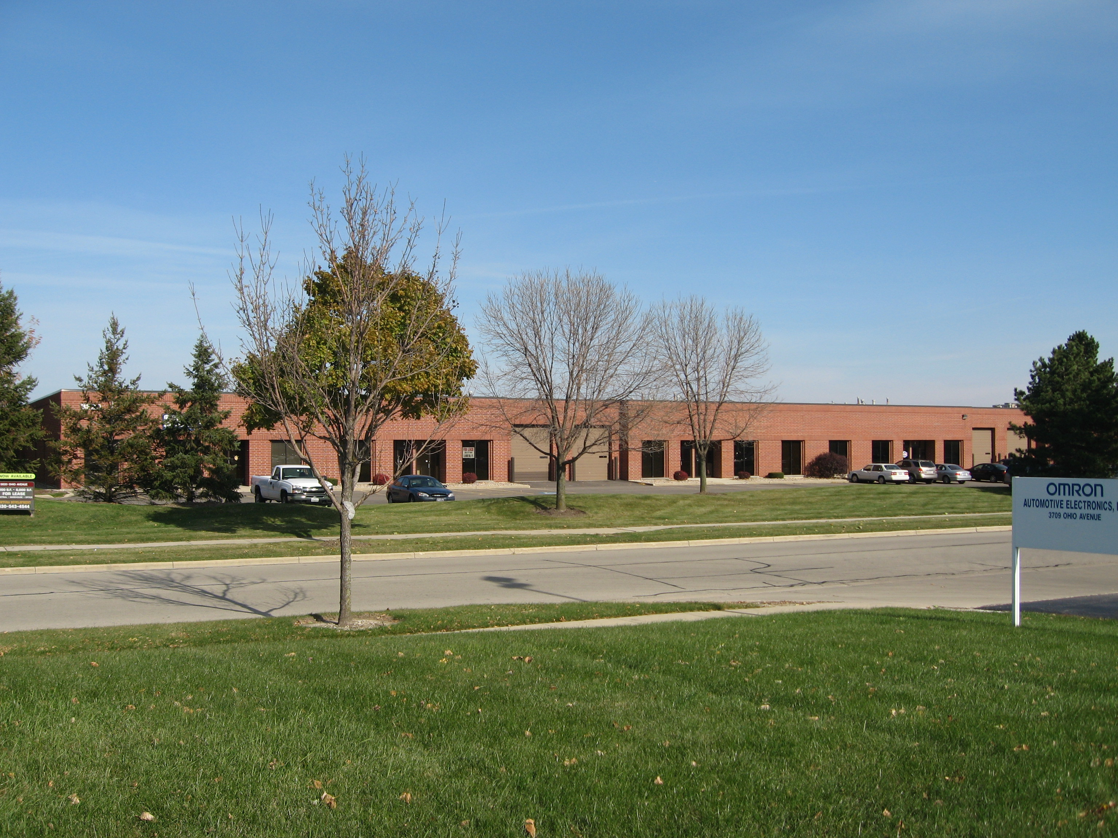

ST. CHARLES, ILLINOIS
INDUSTRIAL UNITS FOR LEASE

ADDRESS: 3820 Ohio Avenue, St. Charles, IL 60174

AVAILABLE UNITS:
Suite Size Office Loading Gross Lease Rate
3 3,000 sf 542 sf DID & Dock $2,500.00 per month
4 3,000 sf 542 sf DID & Dock $2,500.00 per month
6 3,000 sf 542 sf Dock $2,500.00 per month
7 3,000 sf 913 sf DID & Dock $2,625.00 per month
8&9 6,000 sf 1,600 sf DID & Dock $4,800.00 per month
10 3,000 sf 1,070 sf Dock $2,625.00 per month
11 1,752 sf 570 sf DID & Dock $1,525.00 per month
12 3,000 sf 572 sf Dock $2,500.00 per month

OFFICE: Office areas will be delivered with new paint & carpeting!

LOADING: 3 exterior common docks & some units also have a drive-in-door!

CONSTRUCTION: 100% Masonry!

CEILINGS: 14’ Clear

POWER: 200 Amp 3 phase 120/208 Volt

PARKING: Ample

SPRINKLERED: Fully

AVAILABLE: Immediate Occupancy

COMMENTS: Excellent location in the St. Charles Business Park – close to several fine
restaurants & shopping mall; 15 minutes to I-88! Rare opportunity to find small
units For Lease that have access to a Truck Dock!

For more information, contact Theresa Wojtas - Exclusive Agent
630-389-3003 (Office) or 630-606-3253 (Cell)

All information herein is from sources deemed reliable but not guaranteed accurate. Subject to errors, omissions, and to change of price and terms, prior lease, all without notice. The Listing agent makes no warranties or representations about the information contained in this form, therefore, it is the Tenant's/Purchaser’s responsibility to ascertain its requirements and to determine that specifications listed on this listing form are acceptable to the Tenant/Purchaser.

